Streams:
Introduced in Java 8, the Stream API (java.util.stream) is a declarative programming framework designed to process sequences of elements supporting sequential and parallel aggregate operations.
Unlike traditional data structures, a stream does not store elements; rather, it conveys elements from a source (such as a Collection, an array, or an I/O channel) through a pipeline of computational operations.
In modern test automation engineering (e.g., Selenium WebDriver, Playwright, REST Assured, Appium), Streams replace imperative, error-prone for/while loops and temporary mutable accumulators with clean, functional, and self-documenting pipelines.
Core Architecture:

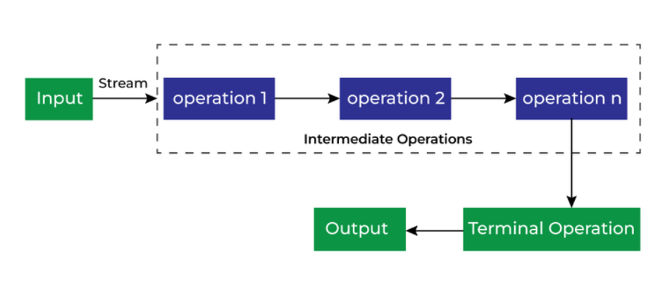

1)Source: Produces the elements (e.g., list.stream(), Arrays.stream(arr), IntStream.rangeClosed(1, 10)).
2)Intermediate Operations: Transform one stream into another. These are lazy; they build an execution graph but perform no computation until a terminal operation triggers evaluation.
3) Terminal Operation: Traverses the pipeline, computes the result, or executes a side effect. Once invoked, the stream is closed and cannot be reused.
. Core Stream Operations Reference
Intermediate Operations (Lazy)
- filter(Predicate<T>): Evaluates each element against a condition; passes only matching elements downstream (e.g., finding strings matching specific criteria or checking prime numbers).
- map(Function<T, R>): Transforms each element of type T into another value or type R (e.g., String::toUpperCase, extracting a property from an entity object).
- flatMap(Function<T, Stream<R>>): Flattens nested structures (e.g., Stream<List<T>> into Stream<T>), merging multiple collections into a single stream.
- distinct(): Removes duplicate elements based on equals() and hashCode().
- sorted() / sorted(Comparator<T>): Sorts elements in natural or comparator-defined order.
- limit(long n): Truncates the stream so it emits no more than n elements (useful for top-k selections).
- skip(long n): Discards the first n elements
Terminal Operations (Eager & Consuming)
- collect(Collector<T, A, R>): Accumulates elements into a mutable container using utilities like Collectors.toList(), Collectors.toSet(), Collectors.joining(", "), or Collectors.groupingBy(...).
- count(): Returns the total number of processed elements as a long.
- forEach(Consumer<T>): Performs an action for each element (primarily used for printing or external side effects).
- findFirst() / findAny(): Returns an Optional<T> containing the first or any element matching upstream criteria.
- anyMatch(Predicate<T>): Returns true if at least one element satisfies the predicate (short-circuiting).
- allMatch(Predicate<T>): Returns true only if every element satisfies the predicate (short-circuiting).
- noneMatch(Predicate<T>): Returns true only if zero elements satisfy the predicate.
- min(Comparator<T>) / max(Comparator<T>): Finds the minimum or maximum element wrapped in an Optional<T>.
- reduce(BinaryOperator<T>): Combines elements into a single summary value via associative accumulation.



